**User Manual**

**Student Lifecycle Management System**

**Module-Examination**

**February 2021, Version-1.0**

**Sustainable Outreach and Universal Leadership Limited**

**Sign off Date Signature Client Signature Consulting**

Table of Contents

About this Manual 3

Module: Examination 4

1. Examination Master: 4

1.1 Exam Type 5

1.2 Assessment Criteria 6

1.3 Grading Scale 6

1.4 Student Exam Block Criteria 7

2. Examination: 8

2.1 Exam Declaration 8

2.2 Exam Application 10

2.3 Exam Paper Setting 11

2.4 Exam Block List 12

2.5 Admit Card 12

How to create an Admit Card? 13

Other Features 14

2.6 Post Exam Declaration 14

2.7 Photocopy Application 15

2.8 Revaluation Application 16

3. Evaluation 18

3.1 Exam Evaluation Plan 18

3.2 Criteria-wise Evaluation 20

3.3 Continuous Evaluation 21

3.4 Final Exam Result 23

4. Tools 24

4.1 Criteria Wise Evaluation Tool 24

4.2 Final Result Declaration Tool 25

5. Transcripts 26

5.1 Leaving Certificate 26

5.2 Provisional Certificate 27

5.3 Migration Certificate 28

8.4 Conduct Certificate 28

8.5 Cumulative Marksheet 29

6. Reports 29

6.1 Course Evaluation Report 29

6.2 Course wise Result 31

# About this Manual

This User Manual acts as a reference for ERP- EduLead by describing its various concepts and abilities, and by leading the user through the basics of EduLead software. It also provides a detailed reference for all of the EduLead SLCM (Student Lifecycle Management) functionalities.

The User Manual describes all the processes and functionalities regarding various modules and its abilities to conduct the smooth transactions and integrations within the modules.

The software EduLead is an open-source, easy to use and customize, actively maintained, economical and well supported.

Throughout this manual it is assumed that the reader has a working knowledge of about Student Lifecycle Management and basic computer skills and knows how to:

* Use keyboard and mouse
* Use web browsers to access the EduLead website
* Locate, open and save data files.
* Edit, cut, paste and text.

The SLCM consists of 3 Modules mainly:

1. Admission
2. Academics
3. Examination

This User Manual consists of the Examination Module for End User reference and guidance. The manual describes how to use the Standard interface. As mentioned, it contains instructions that the users must follow during the operation and servicing of **EduLead**. Diverting from the workflow as mentioned in the user manual may result in errors and non-functioning of the software EduLead. It is advisable that the end users must abide by the instructions as mentioned in the user manual.

# Module: Examination

## Examination Master:

The Examination Masters consists of transactions which would allow to determine and set the values for the Examination Module to process easily. The transactions in Examination Master consists of:

1. Exam Type
2. Assessment Criteria
3. Grading Scale
4. Student Exam Block Criteria

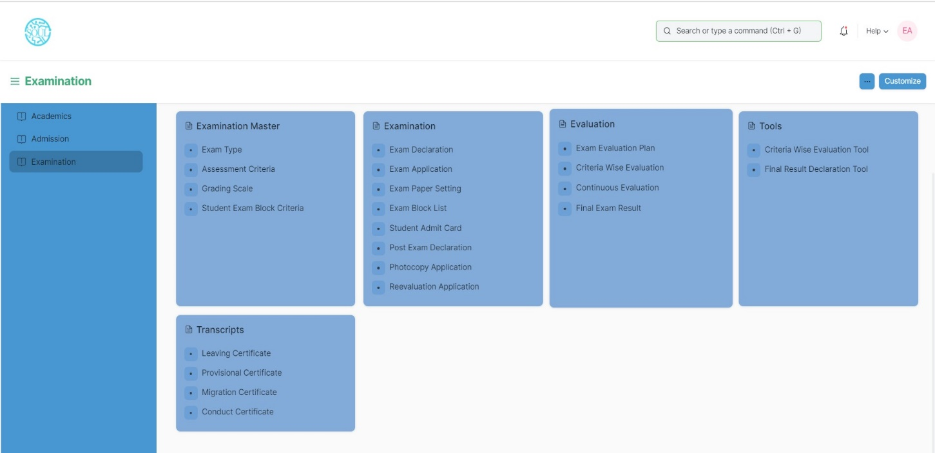

### 1.1 Exam Type

The Exam Type allows you to create and set values for a particular Exam Declaration which shall be beneficial to determine the type of examinations that are being conducted and can be evaluated on the basis of it.

For example, An Exam Declaration can be classified as Mid Term Examination or End Term Examination.

To access Exam Type list, go to:

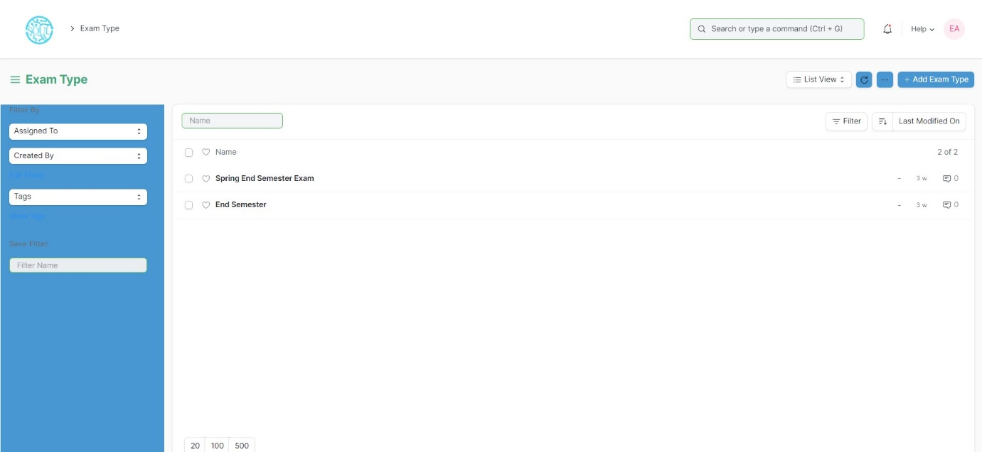Home > Examination > Examination Master > Exam Type

### 1.2 Assessment Criteria

The Assessment Criteria various components of Continuous Evaluation on the basis of which Evaluation shall be conducted.

Also, multiple Assessment Criteria can be grouped together under **Assessment Criteria Group** as well as **Maximum Credit** can be allotted to them. It can also be linked with Exam Declaration if required.

For example, Assessment Criteria can be specified as Mid Term, Practical, End Term, Quiz, Viva, etc.

To access Assessment Criteria list, go to:

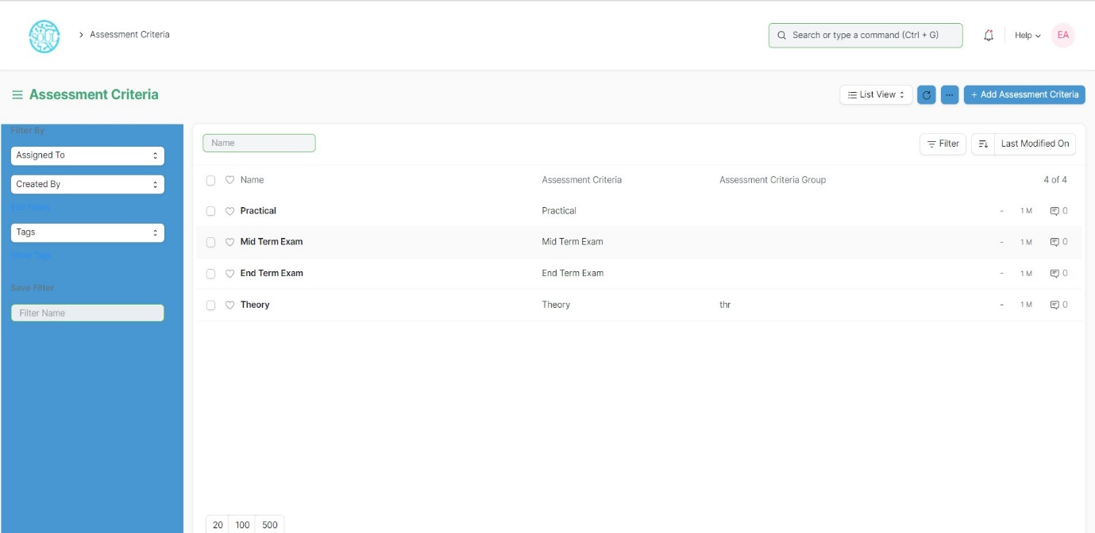Home > Examination > Examination Master > Assessment Criteria

### 1.3 Grading Scale

Under Grading Scale, you can define the threshold for the different grades obtained by the students, based on their scores in the assessment.

For example, Students obtaining a score of 90% and above would be graded as A+, students obtaining a score of 80% and above would be graded A- and so on.

To access Assessment Criteria list, go to:

Home > Examination > Examination Master > Grading Scale

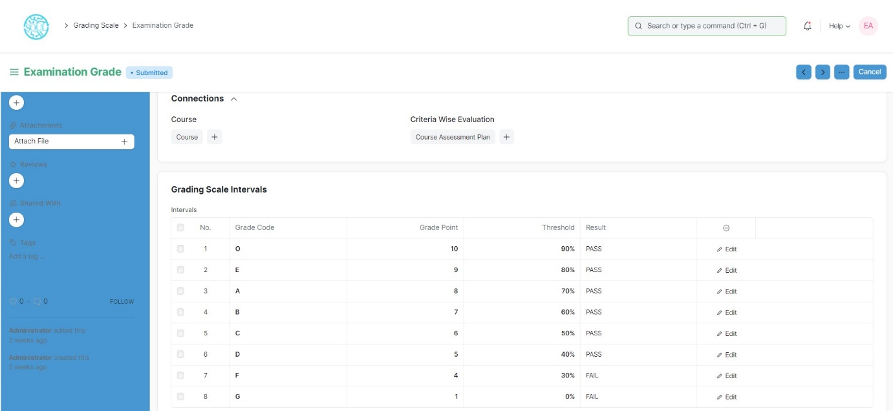

### 1.4 Student Exam Block Criteria

The Student Exam Block Criteria is used to create various criteria based on which students are blocked from applying for an exam declaration.

For example, Attendance, Fees can be used as Student Exam Block Criteria for an Exam Declaration.

To access Assessment Criteria list, go to:

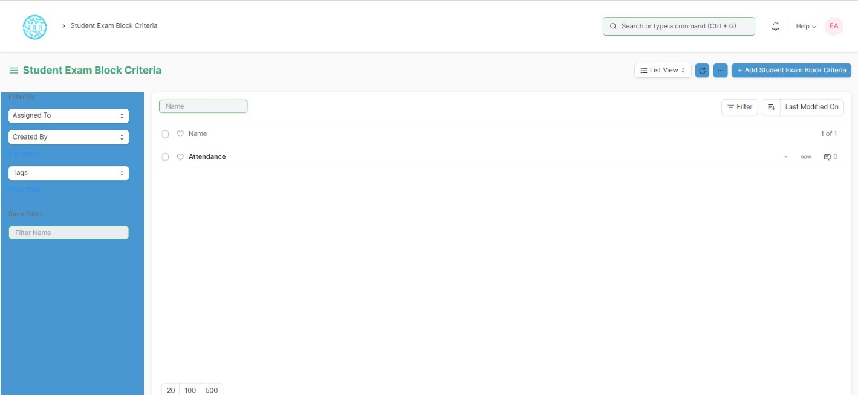Home > Examination > Examination Master > Student Exam Block Criteria

## Examination:

### 2.1 Exam Declaration

The Exam Declaration will allow you to declare an exam for various programs with accordance

to the ‘Academic Calendar template which was used during the start of each session.

To access the Exam Declaration Process, go to:

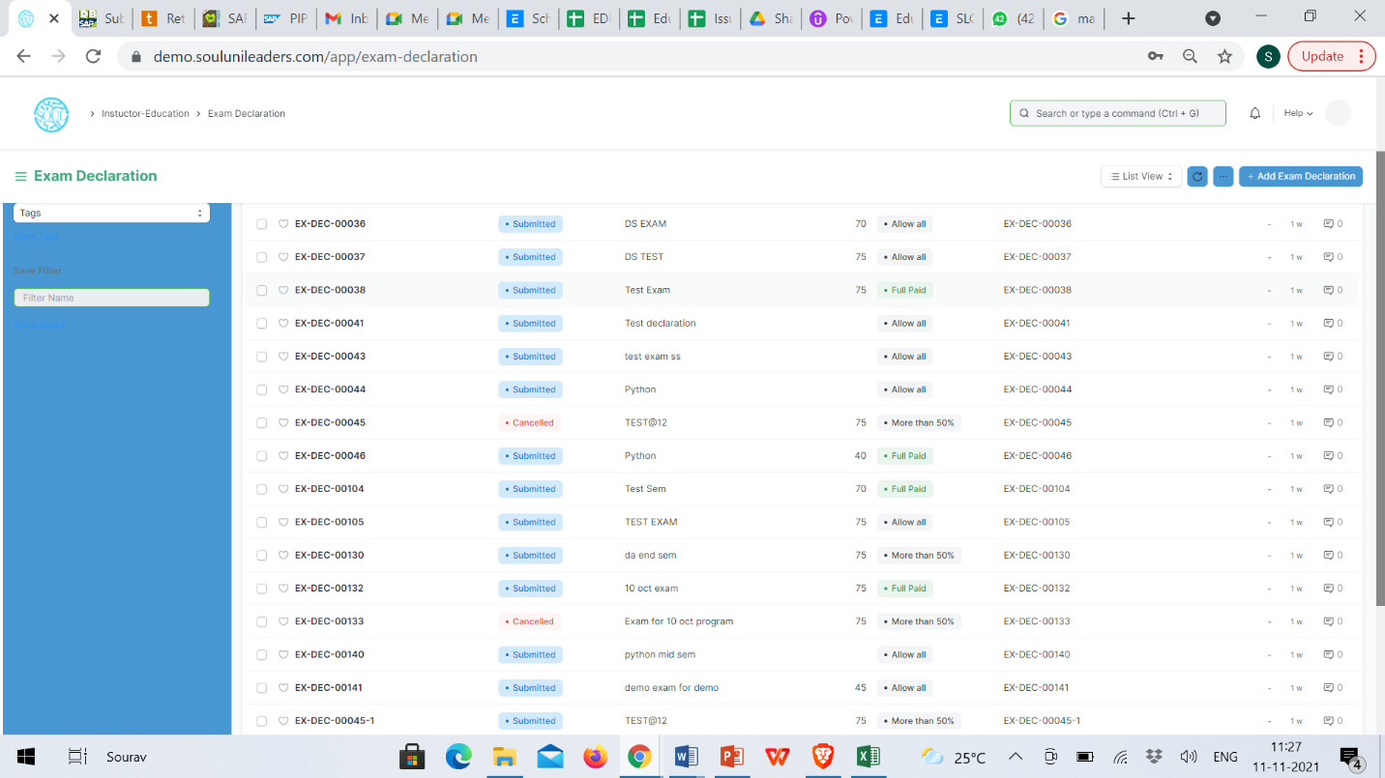Home > Examination > Examination>Exam Declaration

The Exam Declaration can be declared with or without the requirement of an Exam Application.

#### Prerequisites:

1.Academic Calendar

2.Program

3.Academic Year

#### How to create an Exam Declaration?

1. Add Exam Declaration: Enter the Exam Type, Exam Name, Academic Year, Academic Term.
2. If Exam Application is required then mark the checkbox: Enter Application Form Start Date, Application Form End Date
3. Select and add the Exam Start Date.
4. Select and add the Exam End Date.
5. Select and add the Block List Display Date.
6. Select and add the Admit Card Issue Date.
7. Select and add the Exam Program.
8. Semesters related to the selected Exam Program will be displayed on the drop-down list.
9. Select Get Courses.
10. Courses Offered Table:
    1. Courses from the semesters selected are auto populated in the table.
    2. Select and the Examination Date
    3. Change the “From Time” and “To Time” to your desirable schedule.
    4. Total duration (in Hours) will be auto generated.
11. Select and enter the eligibility details:
    1. Select and add Minimum Attendance Criteria
    2. Select the Fee Status from the list of drop-down options
12. Select and add Exam Fees:
    * 1. Select and add Exam Fees if applicable-If Yes, then select and add various fee structures along with due date in the fee structure table according to Student Category.

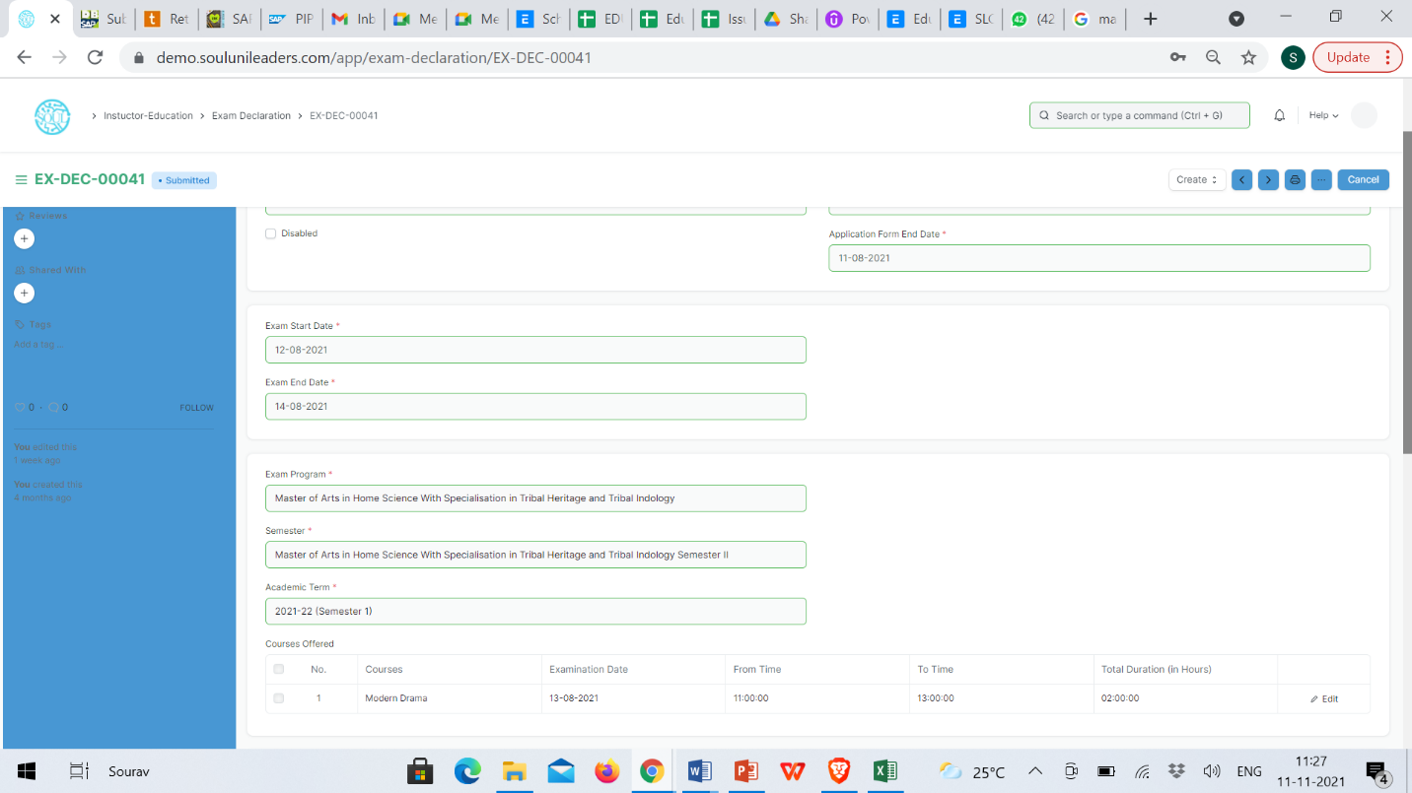

### 2.2 Exam Application

The Exam Application will allow you to apply for an exam that has been declared for a particular program with accordance to the ‘Academic Calendar’ template which was used during the start of each session.

To access the Exam Application Process, go to:

Home > Examination > Examination>Exam Application

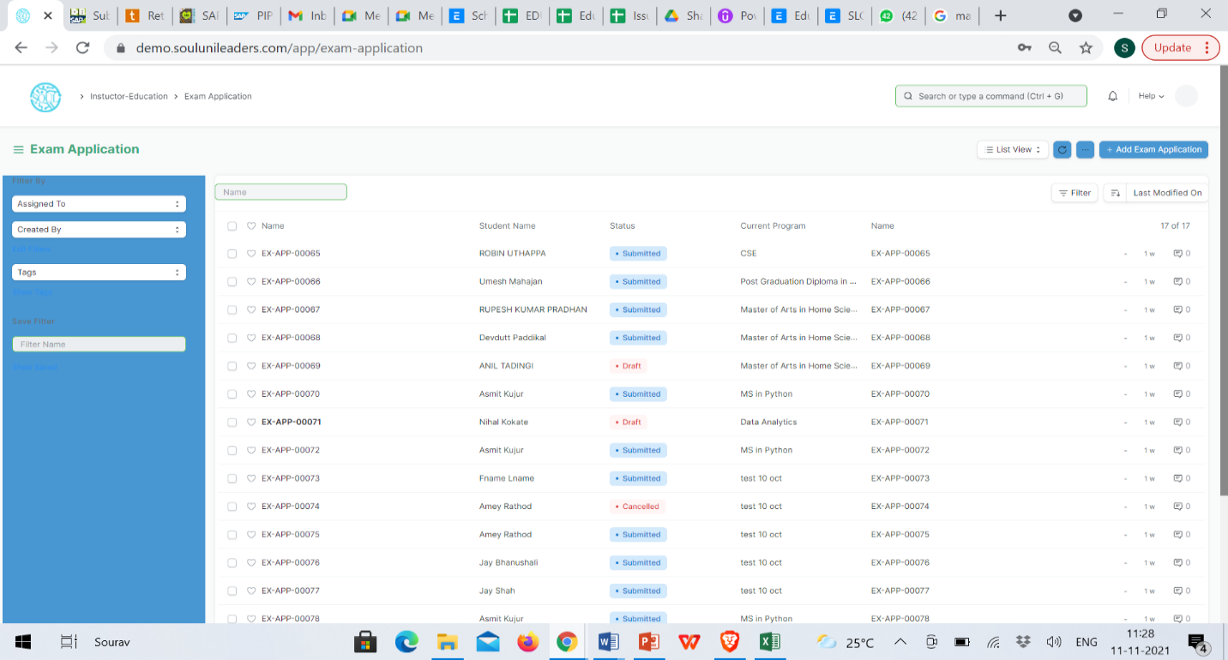

#### Prerequisites:

1.Exam Declaration

#### How to create an Exam Application?

1. Add Exam Application: The current date is auto fixed and cannot be changed.
2. Select and Add Student
3. Student Name automatically is reflected in the below field.
4. Select and Add the Exam Declaration for which is the student is applying.
5. Data is auto fetched for:
   1. Program Academic Year
   2. Academic term
   3. Exam Fees
6. Select the Save button
7. Current Academic Courses will be automatically fetched.

### 2.3 Exam Paper Setting

The Exam Paper Setting is used to prepare paper setting schedules and plan for paper setters and moderators for a particular exam declaration.

To access the Exam Paper Setting, go to:

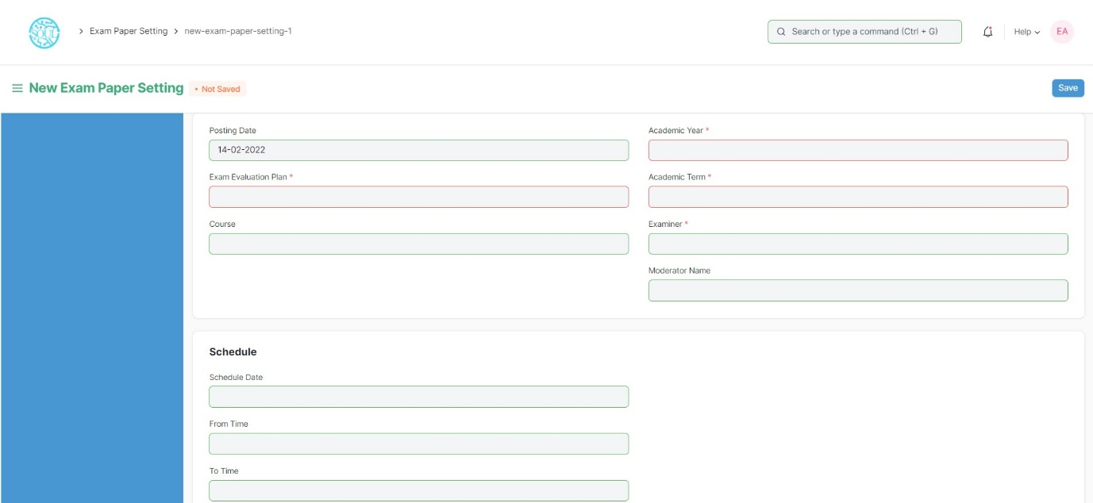Home > Examination > Examination> Exam Paper Setting

#### Prerequisites:

1.Exam Evaluation Plan

2.Exam Declaration

**Note: The Exam Paper Setting is already created as a draft when Exam Evaluation Plan is submitted. The Paper Setter has to only attach the exam paper set for that particular exam declaration and then approved by the Moderator if any. **

#### How to create an Exam Paper Setting?

* + - 1. Select and Add Exam Paper Setting:
      2. Select and Add Exam Evaluation Plan, Academic year, Academic Term.
      3. Select and add Course
      4. Select the Examiner from the dropdown menu and then the Moderator Name.
      5. Select the Schedule Date: Select “From Time” & “To time”.
      6. Select and attach the Paper Copy.
      7. Save.

### 2.4 Exam Block List

The Exam Block List displays the list of students that are blocked from applying for a particular Exam Declaration as they are not being able to clear the eligibility exam criteria.

To access the Student Exam Block List Process, go to:

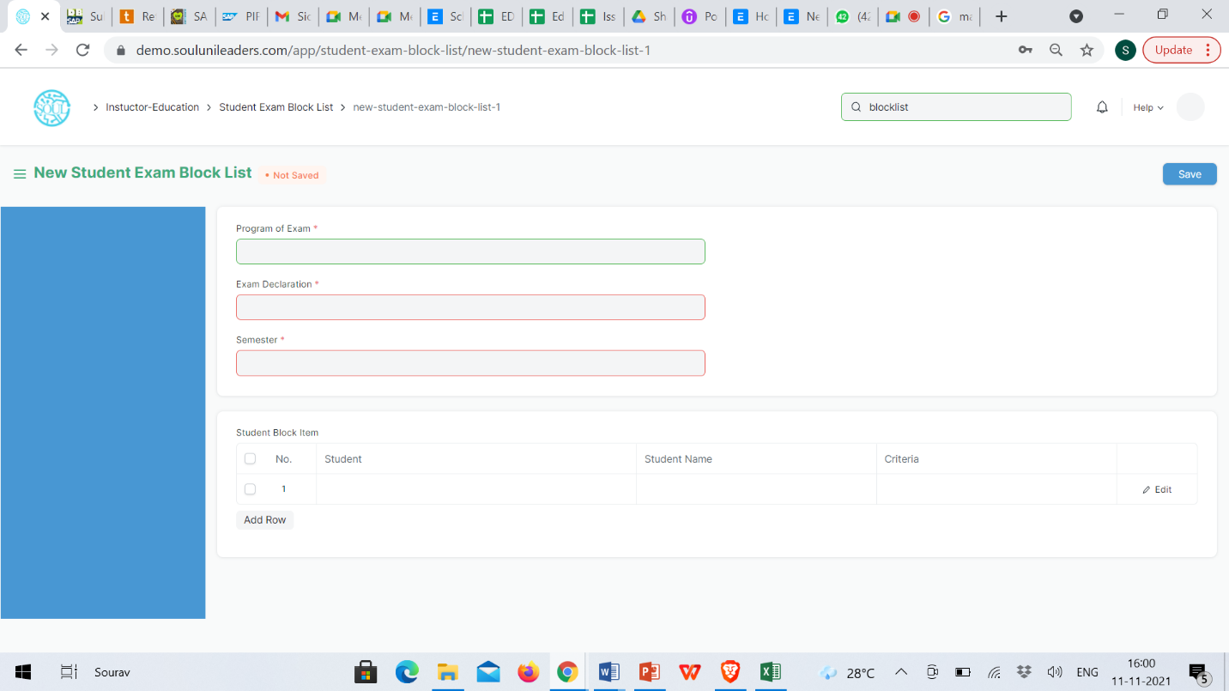Home > Examination > Examination> Exam Block List

#### How to create Student Exam Block List?

1. Add Student Exam Block List: Select and add Program of Exam
2. Select and add Exam Declaration
3. Semester is auto fetched
4. Select and add row in Student Block Item:
   1. Enter Student ID
   2. Student Name is auto fetched
   3. Select and add criteria
5. Select Save button

### 2.5 Admit Card

The Admit Card process is used to download the admit card after exam application has been applied for the particular exam declaration.

To access the Admit Card Process, go to:

Home > Education > Examination> Admit Card

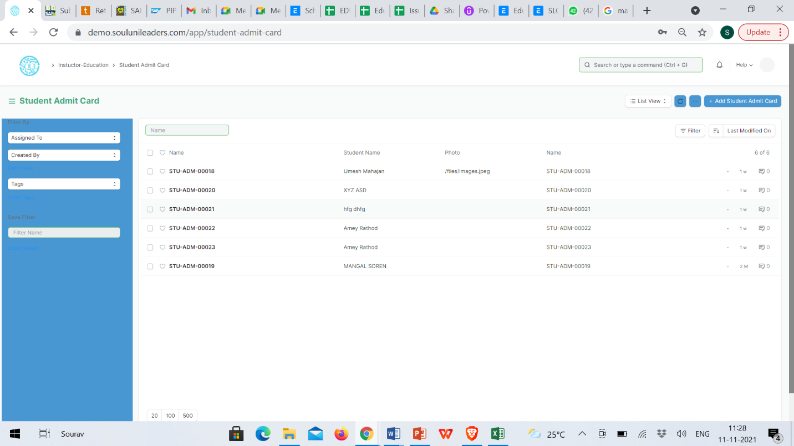

#### Prerequisites

* + - 1. Exam Declaration
      2. Exam Application
      3. Eligibility Criteria
      4. Admit Card Issue Date

### How to create an Admit Card?

1. Select Add Student Admit Card
2. Select and Add Registration No
3. All other fields are auto fetched accordingly
4. Add Save button

### Other Features

1. The Admit card can be view in print form and downloaded.
2. The admit card contains information regarding the exam schedule.
3. It also contains photo of the student.

### 2.6 Post Exam Declaration

There are some processes that needs to be available to the students and institutes, post examination and before result declaration in order to have a fair chance given to students so that they can have their doubts cleared about the marks they secure and the results that are published.

The post exam declaration consists of 2 declarations that are mostly made open for students to apply:

1. Photocopy Application
2. Re-evaluation Application

To access the Post Exam Declaration Process, go to:

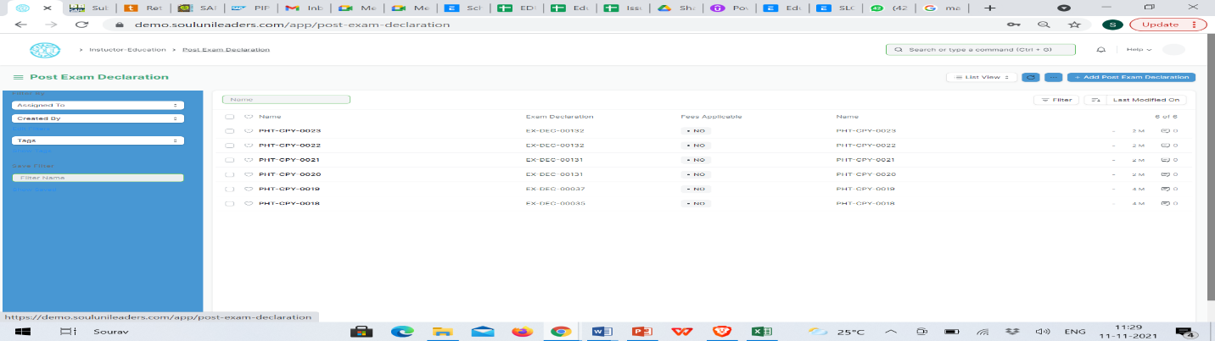Home > Examination > Examination> Post Exam Declaration

#### Prerequisites

1. Exam Declaration
2. Fees Applicable

#### How to create Post Exam Declaration?

1. Select and Post Exam Declaration
2. Select and add Start Date.
3. Select and add End Date
4. Select and add Exam Declaration for which Post Exam Declaration is being issued.
5. Select if Fees Applicable.
   * 1. 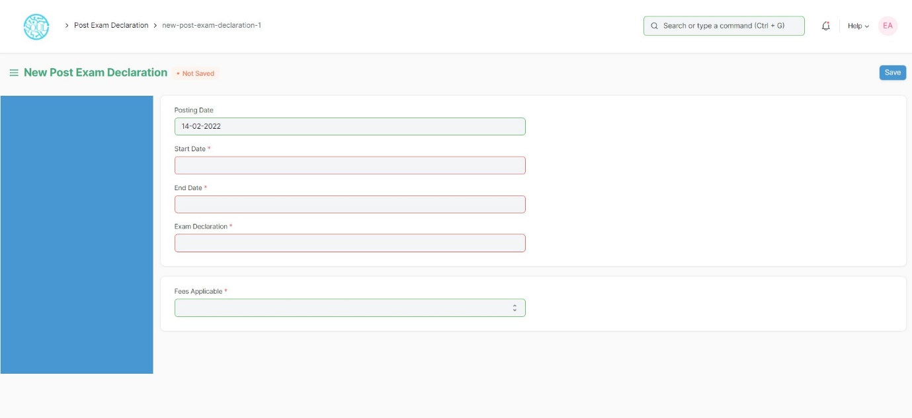Select and add Fee Structure.

### 2.7 Photocopy Application

After a post-exam declaration, if the student wants to view his exam answer sheet, then they apply to photocopy application. The exam section attaches the copy of the student’s scanned answer sheet which is accessible from the student ID. Through this process, the student can raise any issues regarding his evaluation of the answer sheet by the faculty/instructor.

To access the Photocopy Application, go to:

Home > Examination Module > Examination> Photocopy Application

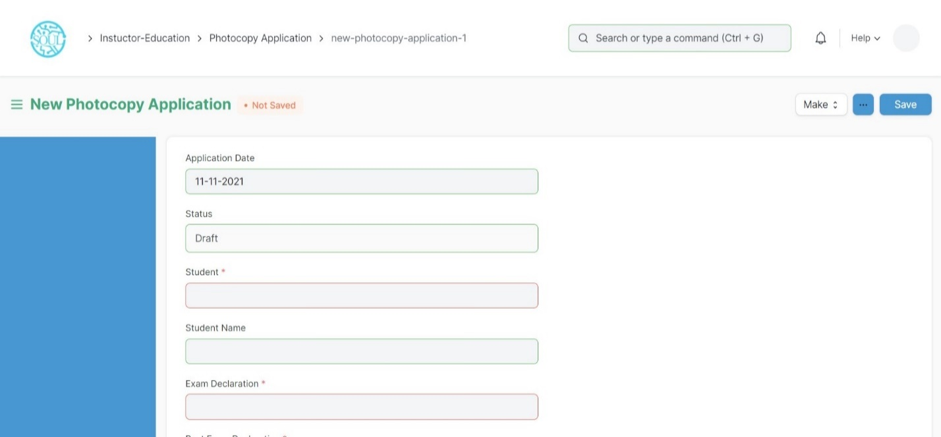

#### Prerequisites

1. Exam Declaration
2. Post Exam Declaration
3. Fees Applicable

#### How to create Photocopy Application?

1. Select and add Photocopy Application
2. Select and add Student Name
3. Select and add Exam Declaration
4. Select and add Post Exam Declaration
5. Select Photocopy Item:
   1. Select and add Course Name from the list of courses for which Post Exam Declaration is issued.
   2. Select attach button and upload photocopy.

### Revaluation Application

After a post-exam declaration, if the student wants to have his answer sheet re-counted for the marks he has been assigned, then he applies for the revaluation application. The re-counted score is placed at the disposal of the student after the revaluation by the Exam section but the scanned copy for the answer sheet is not accessible at the student ID.

To access the Photocopy Application, go to:

Home >Education > Examination> Revaluation Application

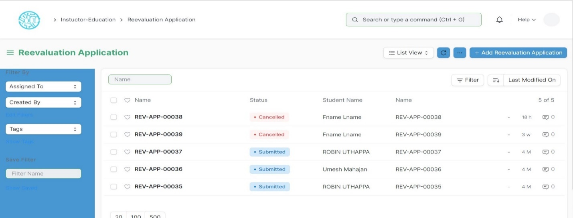

#### Prerequisites

1. Exam Declaration
2. Post Exam Declaration
3. Fees Applicable

#### How to create Revaluation Application?

1. Select and add Reevaluation Application
2. Select and add Student Name
3. Select and add Exam Declaration
4. Select and Post Exam Declaration
5. Select Photocopy Item:
   1. Select and add Course Name from the list of courses for which Post Exam Declaration is issued.
   2. Select attach button and upload photocopy.

## Evaluation

### Exam Evaluation Plan

An Exam Evaluation Plan is a schedule to conduct the examination/assessment of a particular course for a group of students studying that course in an on-going academic term.

To access the Exam Evaluation Plan, go to

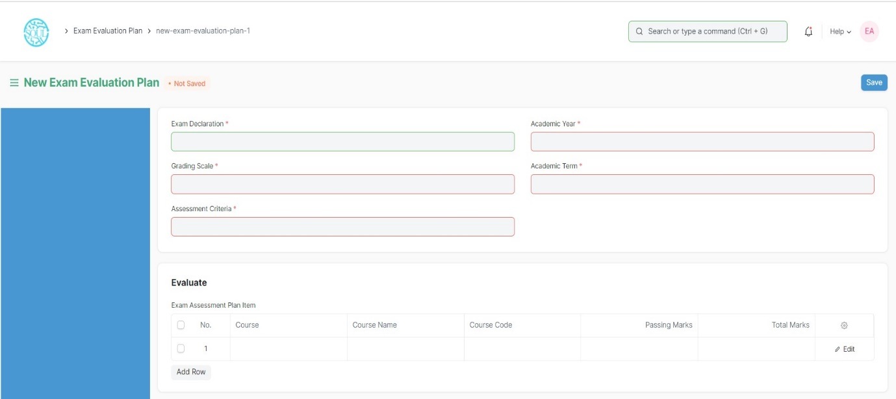Home > Examination > Evaluation > Exam Evaluation Plan

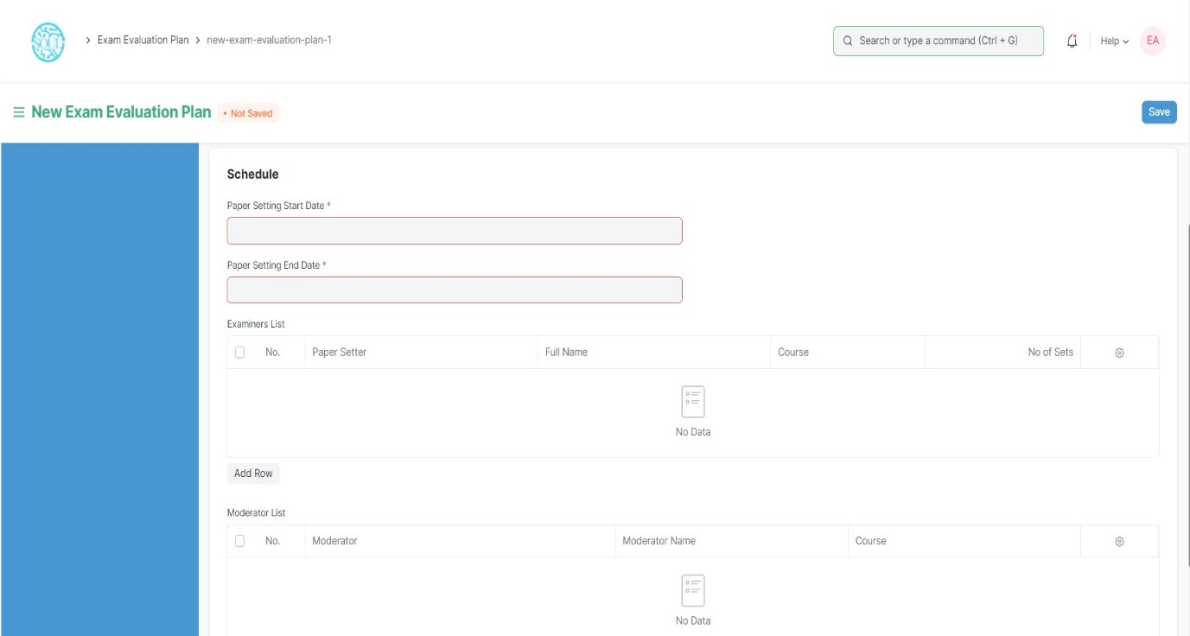

#### Prerequisites

Before creating an Exam Evaluation Plan, it is advisable that you create the following first:

1. Student Group (Based on Exam Declaration)
2. Course
3. Program
4. Evaluation Group
5. Grading Scale

#### How to create an Exam Evaluation Plan?

1. Go to the Exam Evaluation Plan list and click on New.
2. Select the Exam Declaration for which you want to conduct the evaluation plan.
3. Select the Academic Year, Academic Term, Grading Scale, Assessment Criteria for which you are conducting the evaluation plan.
4. The courses for which the exam declaration has been made, gets auto fetched in the “Evaluate” table along with passing marks and total marks.
5. Select the Paper Setting Start Date and Paper Setting End Date.
6. Select the faculties in the Examiners List and select the courses which are present in their respective Instructor Log.
7. Select the faculties as Moderators along with the courses specified to them.
8. Save.
9. Once you save the Exam Evaluation Plan, the Exam Paper Setting would automatically be created for the evaluation which needs to be verified and submitted.
10. Submitted.

#### Features

#### Exam Schedule

1. Schedule Date: Enter the date on which the evaluation is to be conducted.
2. From Time: Enter the start date for the evaluation.
3. To Time: Enter the end time for the evaluation.
4. Room: Select the room in which the evaluation would be conducted.
5. Examiner: Add the name of the Examining Instructor for this assessment.
6. Supervisor: Add the name of the Supervising Instructor for this assessment.

### Criteria-wise Evaluation

Criteria-wise Evaluation allows us to create an evaluation for a particular assessment criterion in a course for a student enrolled in that course.

To access the Criteria-wise Evaluation, go to:

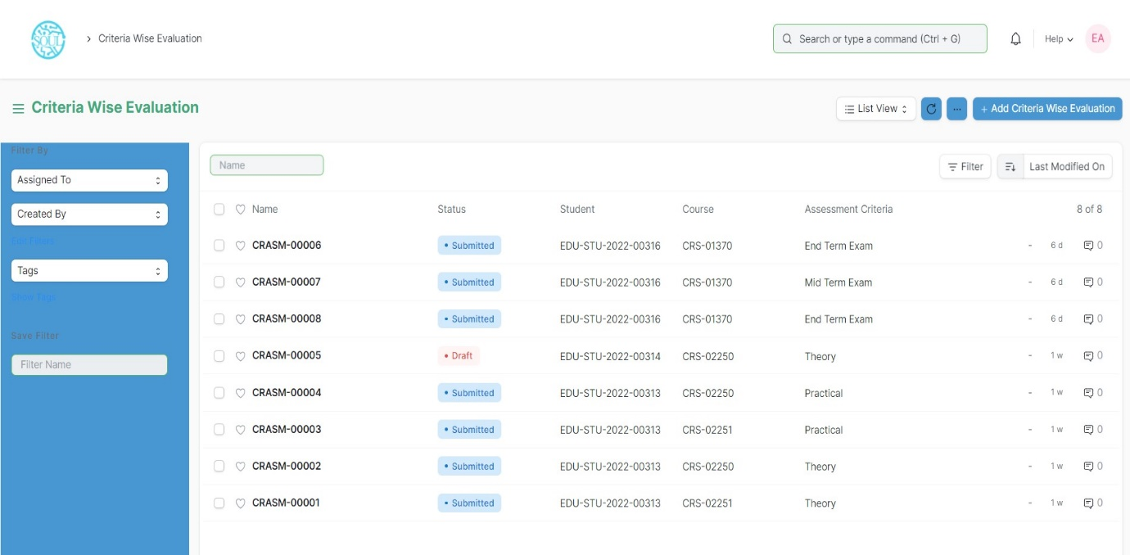Home > Examination > Evaluation > Criteria wise Evaluation

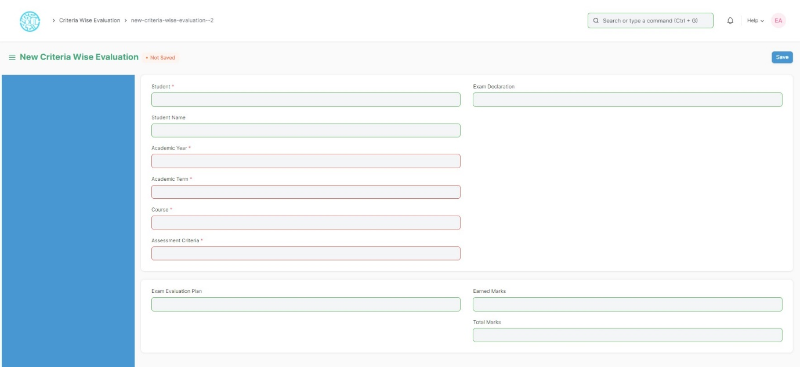

#### Prerequisites

Before creating Criteria-wise Evaluation, it is advisable that you create the following first:

1. Exam Declaration

2. Course

3. Assessment Criteria

4. Exam Evaluation Plan

5. Grading Scale

#### How to create Criteria-wise Evaluation?

1. Go to Criteria Wise Evaluation; Select and add Criteria Wise Evaluation.
2. Select and enter the Student Name
3. Select and enter Academic Year and Academic Term
4. Select the Course from the dropdown list.
5. Select and add Assessment Criteria.
6. Select and add Exam Declaration and Exam Evaluation Plan if any.
7. Save.

### Continuous Evaluation

Continuous Evaluation is used to assess the Assessment Criteria done for a course for an individual student.

To go to Continuous Evaluation, go to:

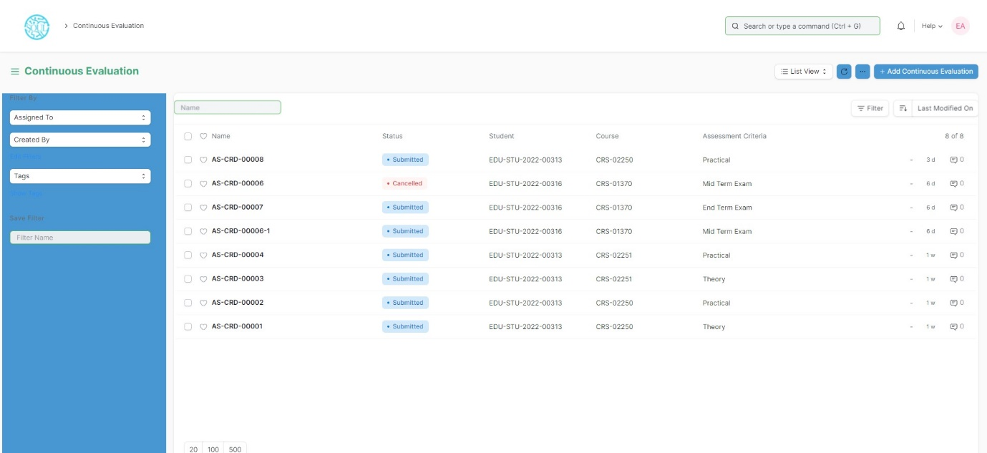Home > Examination > Evaluation > Continuous Evaluation

#### Prerequisites

Before creating Continuous Evaluation, it is advisable that you create the following first:

* + - 1. Criteria wise Evaluation

#### How to create Continuous Evaluation?

1. Go to Continuous Evaluation; Select and add Continuous Evaluation.
2. Select and enter the Student Name
3. Select the Course from the dropdown list.
4. Select and add Assessment Criteria.
5. Select Get Assessments.
6. The Assessment Criteria for that particular course is auto fetched.
7. Enter Grace Marks if required.
8. Earned Credits and Weightage Marks is auto fetched.
9. Enter the Final Marks after any revision.
10. 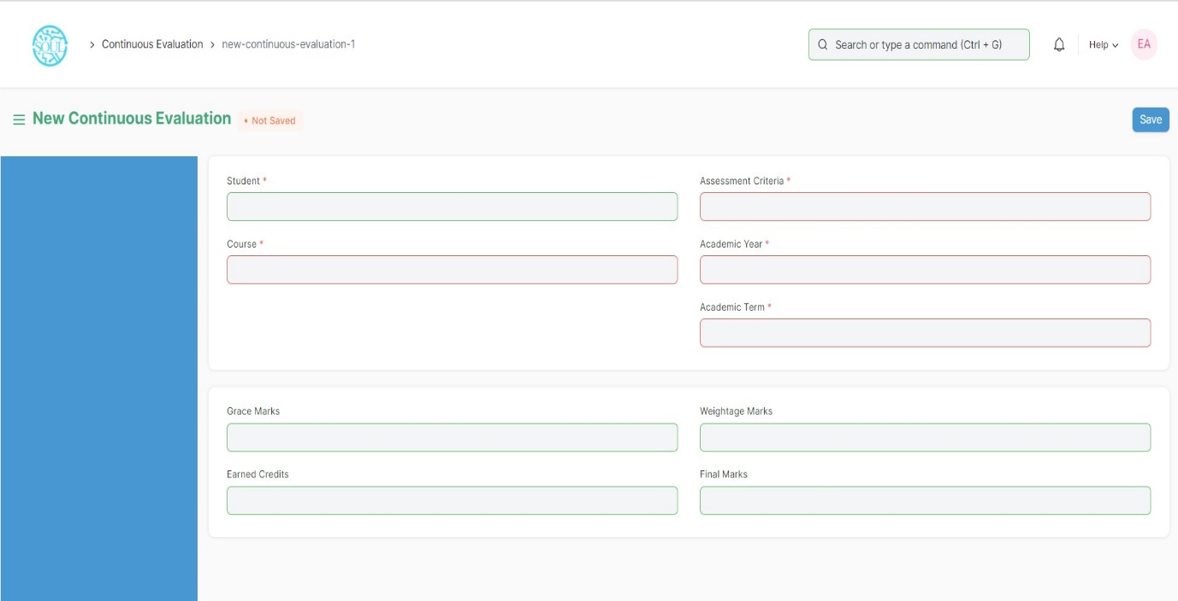Save.

### Final Exam Result

Final Exam Result is used to evaluate the final assessment of a student for a particular semester.

To go to Final Exam Result, go to:

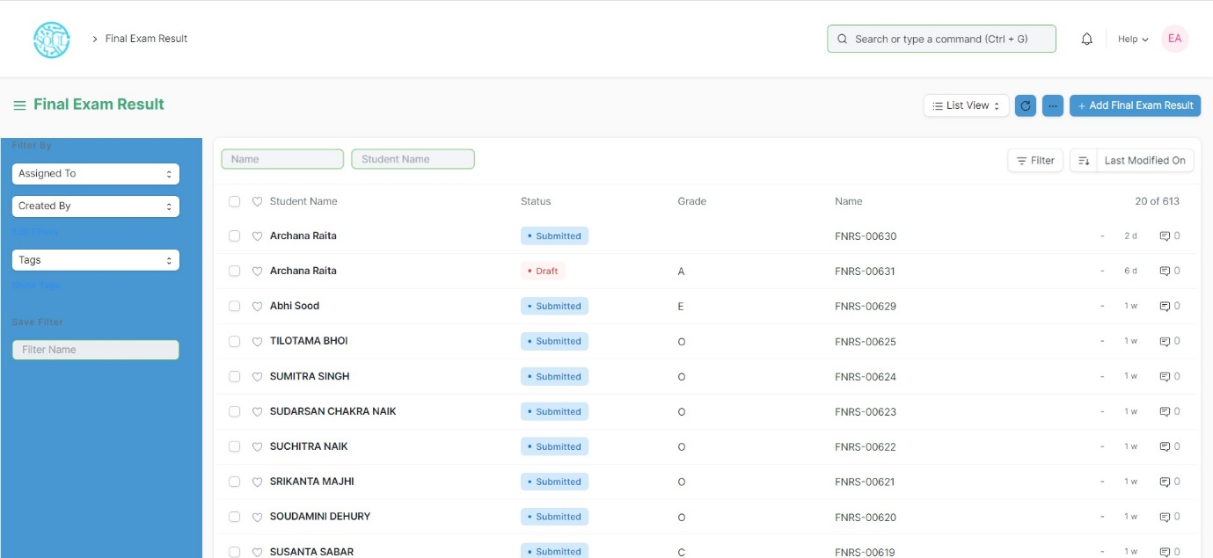Home > Examination > Evaluation > Final Exam Result

#### Prerequisites

Before creating Final Exam Result, it is advisable to create the following first:

* + - 1. Criteria wise Evaluation
      2. Continuous Evaluation

#### How to create Final Exam Result?

1. Go to Final Exam Result; Select and add Final Exam Result.
2. Select and enter the Student Name
3. All the information required is auto fetched.
4. Select and add Grading Scale.
5. Select Get Result.
6. The Assessment Result items for that particular student is auto fetched.
7. The Evaluation Result item is also auto fetched and calculated on the basis of grading scale.
8. The SGPA, Result and Grade is also calculated and automatically fetched.
9. Submit and Save the Final Exam Result.
10. The final exam result is declared for a particular Student.

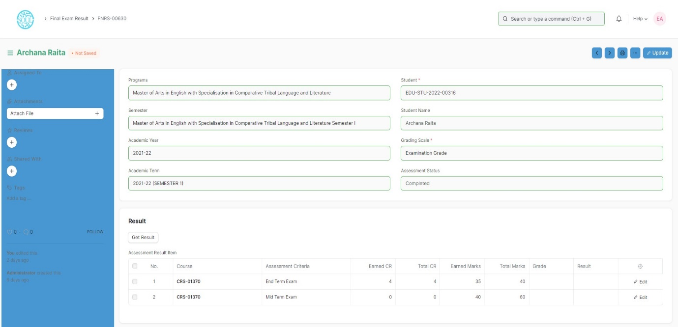

## Tools

### Criteria Wise Evaluation Tool

Criteria Wise Evaluation Tool helps in entering marks earned by the students in a semester for a particular course and particular assessment criteria.

To go to Criteria Wise Evaluation Tool, go to:

Home > Examination > Tools > Criteria Wise Evaluation Tool

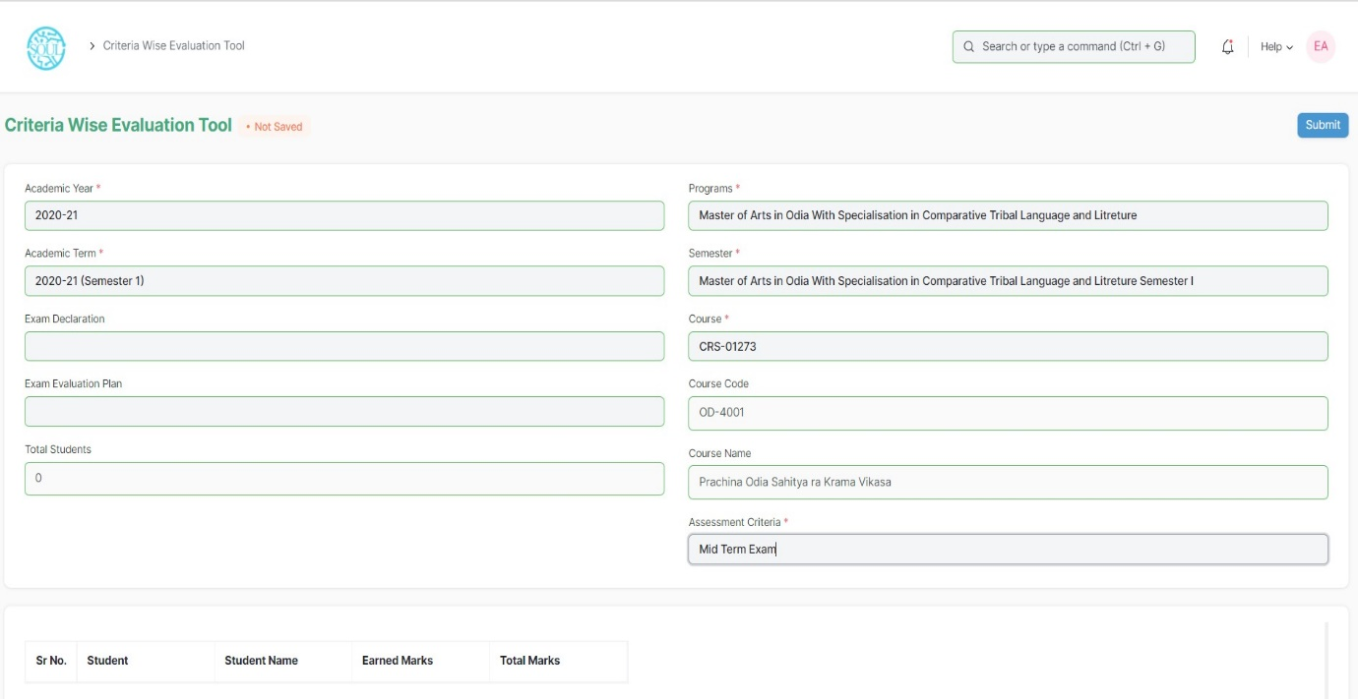

#### How to use Criteria Wise Evaluation Tool?

1. Go to Criteria Wise Evaluation Tool.
2. Select and add Academic Year, Academic Term.
3. Select and add Programs, Semesters.
4. Select and add Course for which assessment criteria is to be evaluated.
5. Select and add Assessment Criteria.
6. If the Assessment Criteria is linked to any exams, then:
   1. Select and add Exam Declaration from the dropdown list.
   2. Select and add Exam Evaluation Plan from the dropdown list.
7. The total number of Students along with the Student list is fetched.
8. Select and enter the marks for each student in the Earned Marks field.
9. Save.

The entries for all the Students’ Criteria Wise Evaluation is created in the Criteria Wise Evaluation Document which can be verified and finally submitted.

### Final Result Declaration Tool

Final Result Declaration Tool is used to declare the final exam results for a particular group/batch of students in a semester.

To go to Final Result Declaration Tool, go to:

Home > Examination > Tools > Final Result Declaration Tool

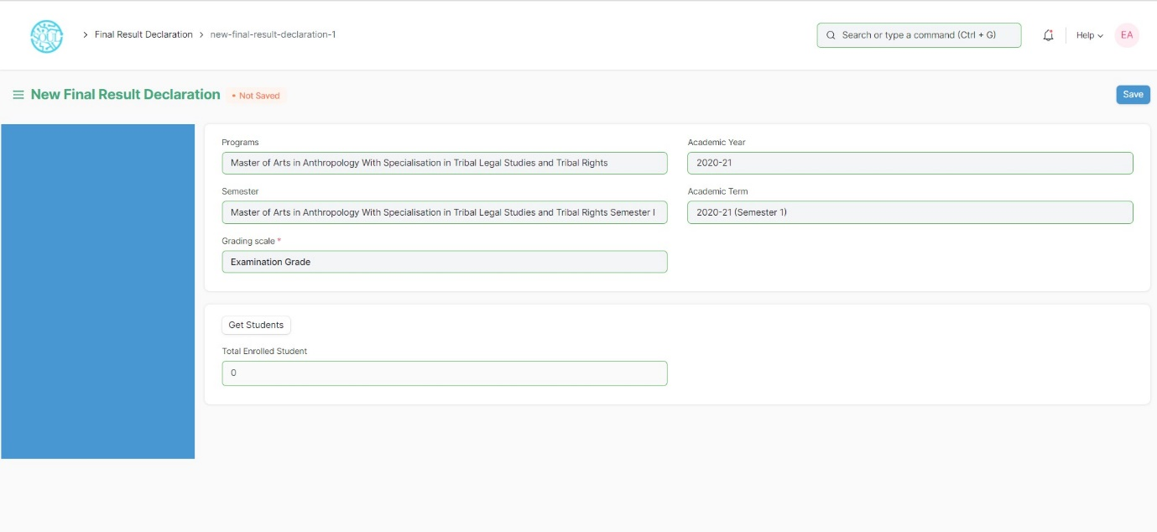

#### How to use Final Result Declaration Tool?

1. Go to Final Result Declaration Tool; Add Final Result Declaration
2. Select and add Programs.
3. Select and add Semester.
4. Select and add Grading Scale.
5. Select and add Academic Year, Academic Term.
6. Select “Get Students”.
7. Total Enrolled Students is shown in the field.
8. The Result Declaration Student List is auto fetched along with Completion Status/Pending Status.
9. Save.
10. The draft entries from the Final Result Declaration Tool is created in Final Exam Result.
11. The draft entries are now then verified and submitted.

## Transcripts

### 5.1 Leaving Certificate

Leaving Certificate is issued when the students have completed their programs. In the ERP the leaving certificate is issued when their Assessment Status is complete. **It is a certificate showing a person has completed his or her time at school**, sometimes requiring the passing of an exam or exams.

To go to Leaving Certificate, go to:

Home > Examination > Transcripts > Leaving Certificate

#### Prerequisites

The Student should have completed his/her respective program.

#### How to create a Leaving Certificate?

1. Go to Leaving Certificate; Add Leaving Certificate
2. Select and enter Student Name.
3. The details related to Student is auto fetched.
4. Select and add Character details.
5. Select and add Annual Exam.
6. Select and add Reason for Leaving the College.
7. Save.
8. Select the Print icon.
9. Change the standard form to Leaving Certificate

### 5.2 Provisional Certificate

Provisional Certificate is issued in **order to make sure that the student is not deprived of any future opportunities in the form of a job or higher education**. It helps the college administration in keeping a record of students who have passed from the university.

To go to Provisional Certificate, go to:

Home > Examination > Transcripts > Provisional Certificate

#### How to create Provisional Certificate?

1. Go to Provisional Certificate; Add Provisional Certificate
2. Select and enter Student Name
3. The related details to Student are auto fetched.
4. Select and add Place.
5. Select and add Name of Degree.
6. Save.
7. Select the Print icon.
8. Change the standard form to Provisional Certificate.

### 5.3 Migration Certificate

Migration Certificate is **a document issued by the concerned University or Board in which one studies**. It helps in getting admission to another institution or any education board and it is issued at the completion of the course along with other necessary documents.

To go to Migration Certificate, go to:

Home > Examination > Transcripts > Migration Certificate

#### How to create Migration Certificate?

1. Go to Migration Certificate; Add Migration Certificate.
2. Select and enter Student Name
3. The related details of the Student are auto fetched.
4. Select and add Place.
5. Select and add Name of Degree.
6. Save.
7. Select the Print icon.
8. Change the standard form to Migration Certificate.

### Conduct Certificate

A conduct certificate **specifies the behavior of an individual during a period of time, in an official place**. It is also sometimes referred to as a character certificate. A conduct certificate is given to a student when he wants to get admission in another institute or in case of transfer.

To go to Conduct Certificate, go to:

Home > Examination > Transcripts > Conduct Certificate

#### How to create Conduct Certificate?

1. Go to Conduct Certificate; Add Conduct Certificate.
2. Select and enter Student Name.
3. The related details of the Student are auto fetched.
4. Select and add Place
5. Add name of degree.
6. Save.
7. Select the Print icon.
8. Change the standard form to Conduct Certificate.

### Cumulative Marksheet

Cumulative Marksheet is a compilation of all the semesters with their grades in a single certificate. The Cumulative marksheet will have a list of subjects, grades obtained and CGPA (Cumulative Grade Point Average). And also details of students, such as roll number, name, age and date of birth, program enrollment.

To go to Cumulative Marksheet, go to:

Home > Examination > Transcripts > Conduct Certificate

#### How to create Cumulative Marksheet?

1. Go to Cumulative Marksheet; Add Cumulative Marksheet.
2. Select and enter Student Name.
3. The related details of the Student are auto fetched.
4. Save.
5. Select the Print icon.
6. Change the standard form to Cumulative Marksheet.
7. Print the Cumulative Marksheet.

## Reports

### Course Evaluation Report

The Course Evaluation Report displays **a summary of information for course evaluation data** of a student.

The Evaluation Report can be used to derive the reports of evaluation relative to any of the following fields:

1. Student Group
2. Academic Year
3. Academic Term
4. Programs
5. Semester
6. Course
7. Course Evaluation Criteria

To go to Course Evaluation Report, go to:

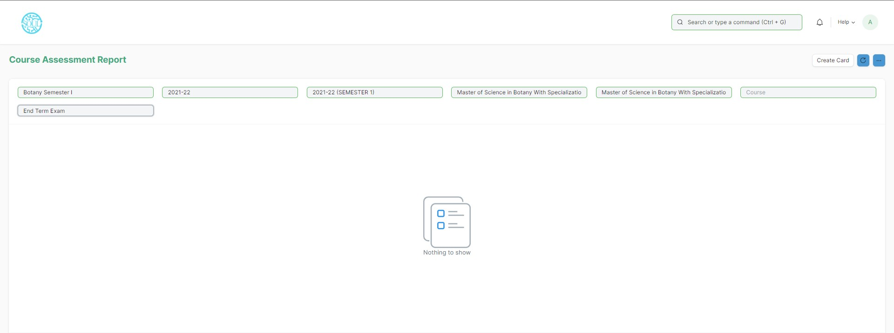Home > Examination > Reports > Course Evaluation Report

#### How to create a Course Evaluation Report?

1. Go to Course Evaluation Report
2. Select and enter Student Group
3. Select and enter Academic Year, Academic Term
4. Select and enter Programs
5. Select and enter Semester
6. Select and enter Course
7. Select and enter Course Assessment Criteria.
8. Save.

#### Features

The Course Evaluation Report can be generated with respect to any values/fields.

In Course Evaluation Report, extra values/fields can also be added to view the report.

The Report can be edited, exported and emailed also.

### Course wise Result

The Course Wise Result Report displays a summary of information of students’ performance for that particular enrolled course/subject.

The Course Wise Result Report can be generated using the values for any of the following fields:

* + - 1. Programs
      2. Semester
      3. Course
      4. Academic Term
      5. Academic Year
      6. Grading Scale

To go to Course Wise Result Report, go to:

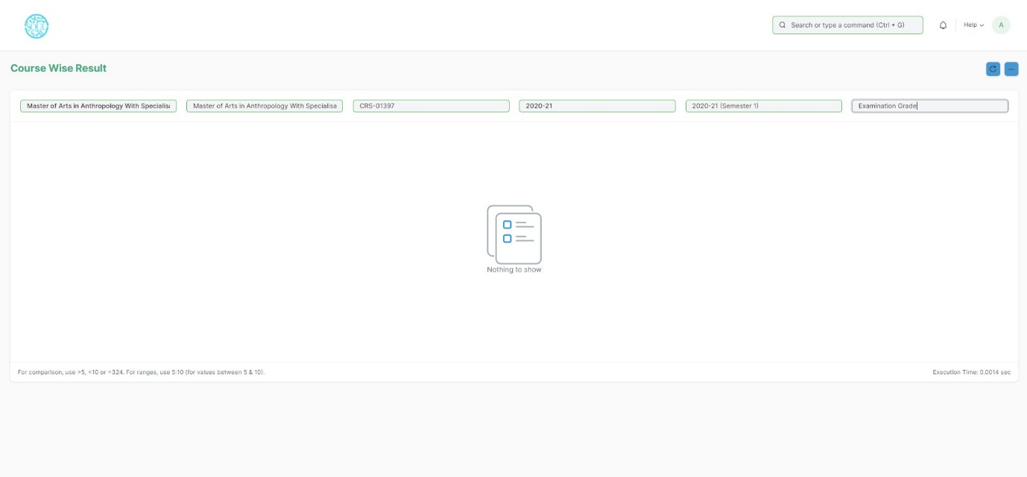Home > Examination > Reports > Course Wise Result Report

#### Prerequisites

Programs

Academic Year

#### How to generate a Course Wise Result report?

1. Go to Course Wise Result Report
2. Select Show Report
3. Select and enter Program(mandatory)
4. Select and enter Semester
5. Select and enter Course
6. Select and enter Academic Year(mandatory)
7. Select and enter Academic Term.
8. Select and enter Grading Scale.
9. Print or export the generated report.